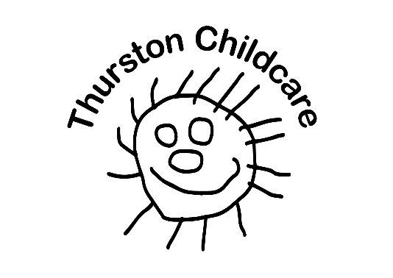

The Nest

Care for children age range 2 – 3 years in the Fledglings grounds

Our cosy new Nest building has a range of play and sensory equipment. Our room is light, natural and creates a stimulating environment where your child can explore and learn. We have on offer a variety of different activities that promote learning through play, exploration and discovery. We make sure that we have experiences such as paint, water, sand on offer for every session, as well as the chance for children to manipulate/malleable activities.

We employ qualified practitioners who are skilled and experienced, able to meet the needs of your children. Positive and strong relationships are built with members of staff which equals confident learning and development.

The ‘key person’ system which operates across all settings is embedded in our Preschool. A key person ensures continuity of care and allows staff too really to get to know your children. The key person is responsible for the child’s care routines, nappy changes and other individual needs. The key person will also be responsible for completing Tapestry and termly reports. After a few weeks we will choose a key person based on who your child seems to have built the best relationship with.

The setting is divided into different areas, e.g. sensory, messy play, quiet area, construction area, reading area and much more, the children are able to access the indoor/outdoor environment with doors and gates leading to the Nest’s own garden area. This is lovely for the younger children within in the setting and it allows our children to mix and perhaps allow siblings, cousins and older friends to solidify relationships. We have a ‘cosy’ reading area and a huge selection of age and stage related toys and resources. Our equipment is at a low storage level so that the children can choose freely when playing or selecting activities.
- Building / construction area –these include Small World toys (such as farm, castle, jungle animals, train track and cars) as well as a variety of building bricks and blocks.
- Art and craft area – with a variety of paints, papers, pens and modelling items allowing the children to express their creative side.
- Role play / home area – this area allows the children to dress up and recreate familiar scenes, such as an ice-cream parlour, washing the car etc.
- Books and quiet areas – here the children have some space for a quiet time activity – either sharing stories or rhymes with friends and practitioners or completing jigsaw puzzles.
- Mark making areas – which includes a selection of pens, pencils and paper for the children to explore early writing or using wet sand to mark make in
- Malleable play and messy play area – Every day in the malleable area the staff provide exciting play not often offered at home this might include jelly, cereals, rice, pasta, playdough, shaving foam, glitter and gloop.
‘At times in the first 2 years of life the brain is making a million connections every Second’ Tuning in to Two Year Olds (2014)
‘If (two year olds) are supported through these changes by a close partnership between parents and practitioners who share the wonder and excitement of two year olds, this can have a life – long impact on children’s learning, and on their enjoyment of life.’ Tuning in to Two Year Olds (2014)
We ensure that we have a quiet area, cuddly toys, treasure baskets, family photos smaller ride-on’s and toys that appropriate. We ensure that we are on the child’s level with speech and language and extend their vocabulary. We encourage children to become independent and to take risks or to go out of their comfort zone.
No one knows your child better than you, so our partnership with parents/carers are integral to our way of working. We hold termly parents’ meetings ensuring you have the time to discuss your child’s individual needs and progress with their appointed key person. However, our ‘open-door’ policy means that parents are welcome to come and speak to us at any time.

We promote home learning, and encourage parents to participate and contribute to their child’s development, sharing information on a daily basis.
Tapestry is a great way of sharing your child’s wow moments and adventures from the weekend or family holidays. Tapestry is an online learning journey. Parents or carers are able to view their child’s progress, the activities provided for them, and how much fun they’re having, whilst also uploading their own comments and media.
The communication between staff and parents that Tapestry enables, helps build a shared understanding of how every child can reach their full potential, from birth to the end of primary school. The Tapestry online learning journal is also available as an easy-to-use, secure app, meaning capturing key learning moments, and videoing milestones are even easier.

